What Is REST?
REST represents Representational State Transfer. REST is an architectural style in which every resource is addressed by using a unique URI. In Microsoft Dynamics CRM, a resource can be an entity collection or a record.
REST works the way the Internet works. You interact with resources by using HTTP verbs such as GET, POST, MERGE, and DELETE. Various libraries can be used to process the HTTP requests and responses. REST provides a standard interface that you can use with any programming language. REST allows for either synchronous or asynchronous processing of operations. The capability to perform asynchronous operations makes REST well suited for AJAX and Silverlight clients.
Microsoft Dynamics CRM 2011 uses the Windows Communication Foundation (WCF) Data Services framework to provide an Open Data Protocol (OData) endpoint that is a REST-based data service. This endpoint is called the Organization Data Service. In Microsoft Dynamics CRM, the service root URI is:
- Performs create, retrieve, update and delete operations using the REST endpoint with JScript and jQuery.
- Uses jQuery, a popular library that includes capabilities to perform data operations using the $.ajax method.

Copy Code
[Your Organization Root URL]/xrmservices/2011/organizationdata.svc
The following table lists the query string options defined in the OData protocol that are implemented in the REST endpoint for Microsoft Dynamics CRM 2011.
Option | Description
$expand | Directs that related records should be retrieved in the record or collection being retrieved.
$filter | Specifies an expression or function that must evaluate to ‘true’ for a record to be returned in the collection.
$orderby | Determines what values are used to order a collection of records.
$select | Specifies a sub set of properties to return.
$skip | Sets the number of records to skip before it retrieves records in a collection.
$top | Determines the maximum number of records to return.

Each time that you retrieve records, only the top 50 records in your query are returned. If there are more than 50 records, there will be a <link rel="next" href="<url to next set of records>" > node in XML or a JSON __next property at the end of the result set

Organization Service:
The IOrganizationService Web service provides access to the business data and metadata of your organization by using the SOAP protocol.

Organization Data Service:

This Open Data (OData) Web service provides access to the business data of your organization by exposing a REST API. This link opens the Conceptual Schema Definition Language (CSDL) document that describes how to access your data by using this API

In terms of limitations the two (there are more) main parts that jump to mind are:
- With REST you can’t do everything SOAP can do. In REST you cannot perform actions that involve; assigning, metadata and execute messages (e.g. CreateRequest). However you can perform all the standard create, retrieve, update and delete (CRUD) calls, and associating and disassociating (AD) records.
- CRM’s implementation of OData hasn’t implemented every feature of the OData protocol, the most obvious being ‘count’.

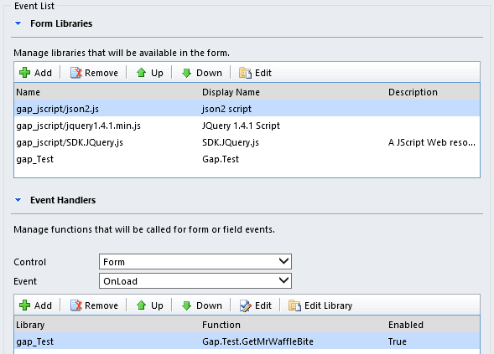
Open the fax entity and you should be presented with a screen as follows. Exciting stuff.
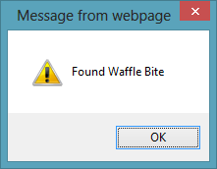
I really like this approach as the library nicely encapsulates all the web service code, you just have to include a couple of libraries in the form and rest of it is pretty straight forward.

